**Assignment 18/04/2024**

**1. Write an HTML code to display images as in the following given output by using table and image tags.**

**Code:**

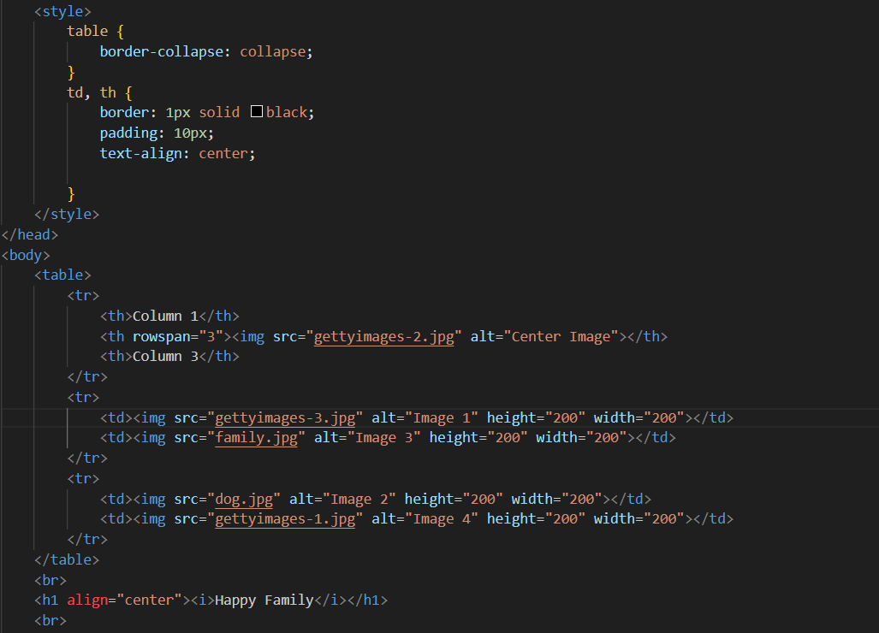

**Output**

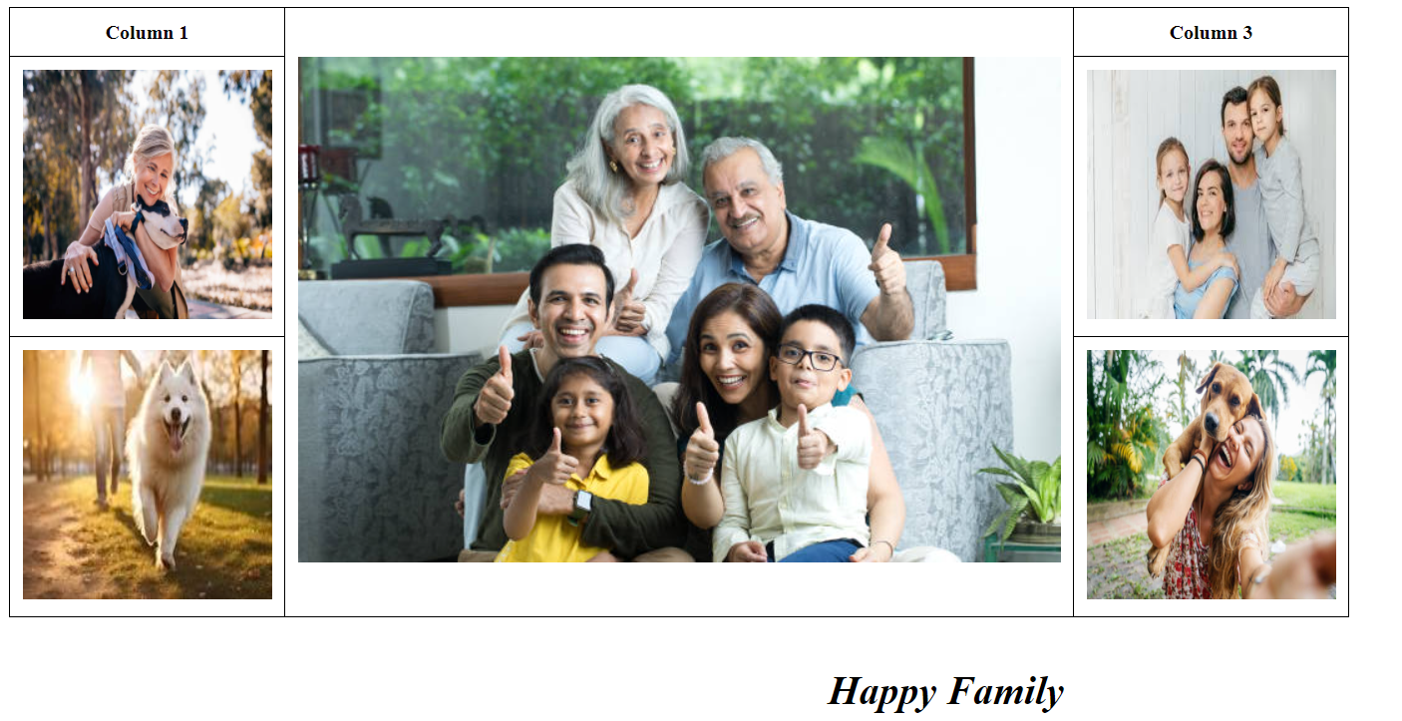

**2. Write an HTML document table with lists of veg food and Non-veg with unordered lists.**

**Code:**

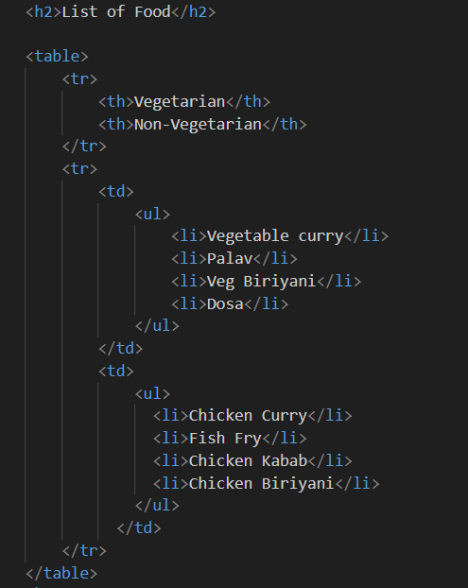

**Output:**

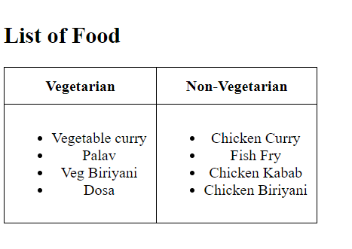

**3. Write an HTML document to play audio and video files.**

**Code:**

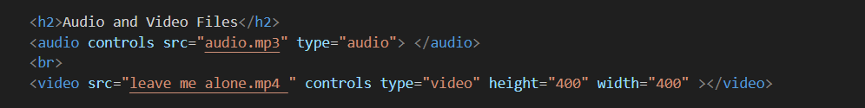

**Result:**

